Medical Store System – Login for Users & Admin

This mini project is one of the modules created for Medical Store using SAP ABAP. This module is for log-in into the online Medical Shop which is supposed to be used for keeping records and selling medicine online.

Assumptions

* Only Admin has the right to perform DML operations on the database.
* But before doing it Admin should know ACCESS KEY and login into account.
* Admin can add new user with default 3 digit password 123.
* Later user can change his/her password once the account is assigned.

Functionalities

* Admin can see all registered USERS.
* Admin can see the details of all users except password and his/her login time.
* Admin can delete any user.
* Admin can update information of user.
* Admin can add any user with basic details like name, contact, username, etc.
* User has to provide all necessary information.
* States can be selected using help box.

Password Security

* Password of all users and admin are secured and protected.
* Passwords are real-time and re-inbuilt by program to make it instantaneous.
* Passwords are encrypted in a way such that they cannot be used further and even if it is copied from database.

SCREENS

1. Login Screen

* Enables user to login with username and password details.

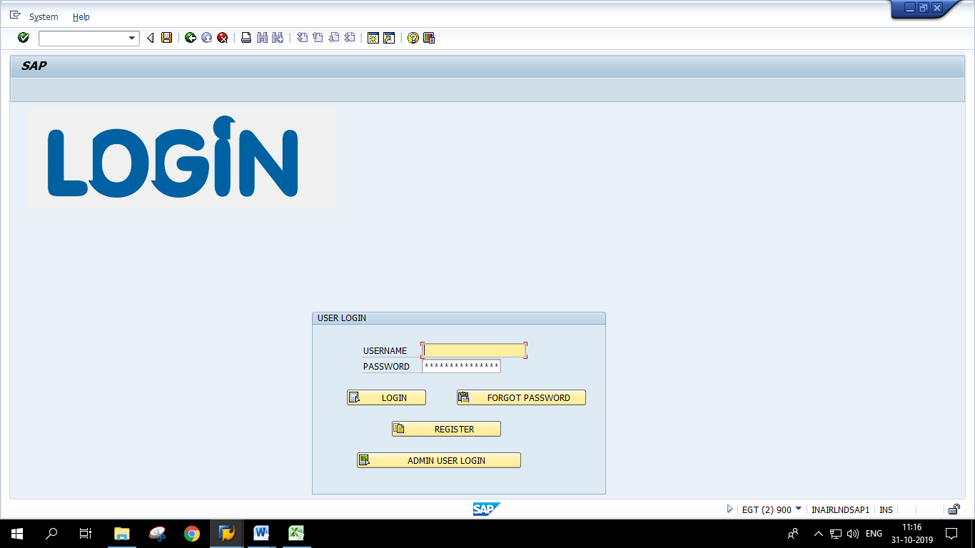

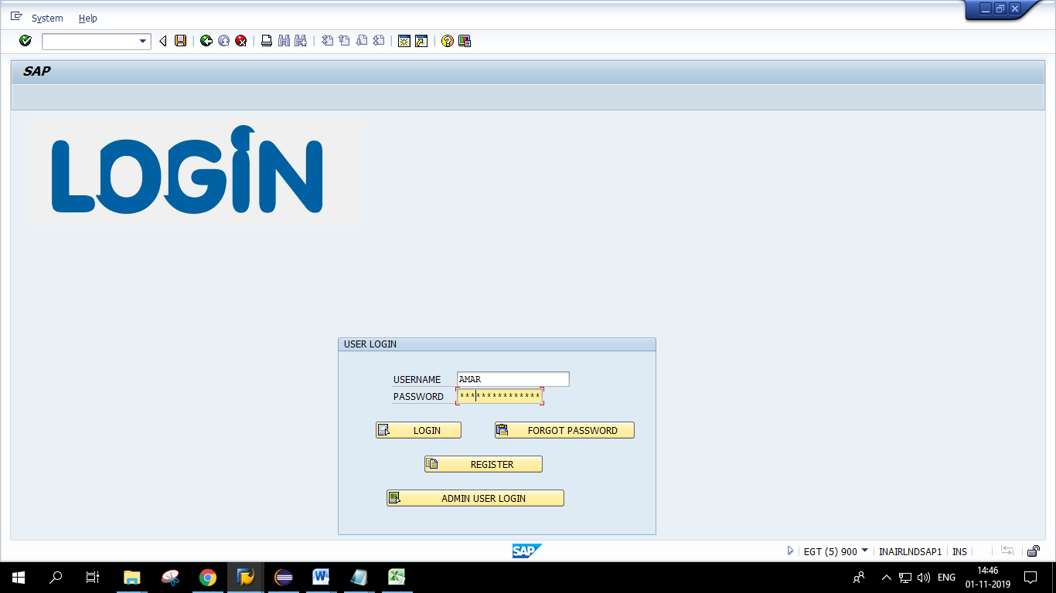

1. Logged-in Screen for User

* The vendor medicine data will be displayed in the given area by another project member.

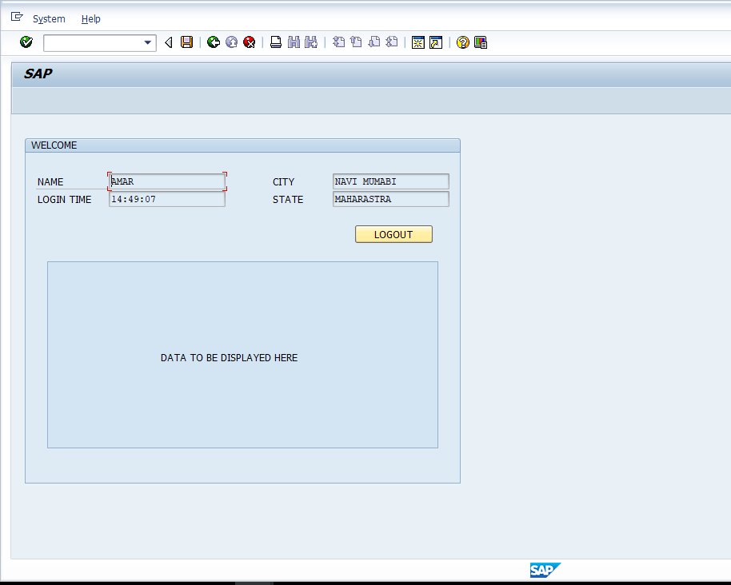

* Logout & come to main screen.

1. Registration screen for user.

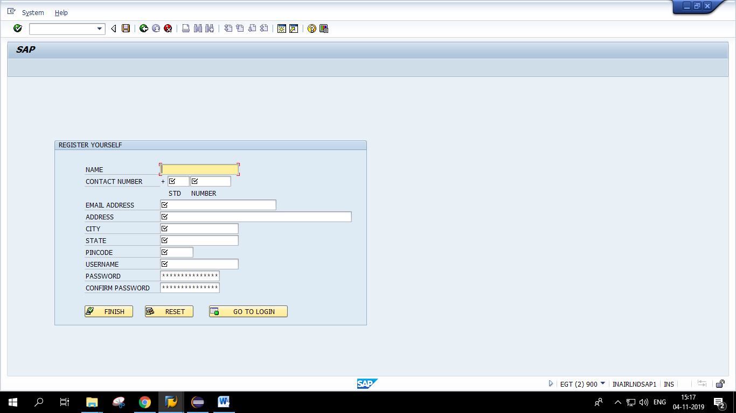

1. Login screen for admin.  
   New User can register by clicking at register push button and provide details.

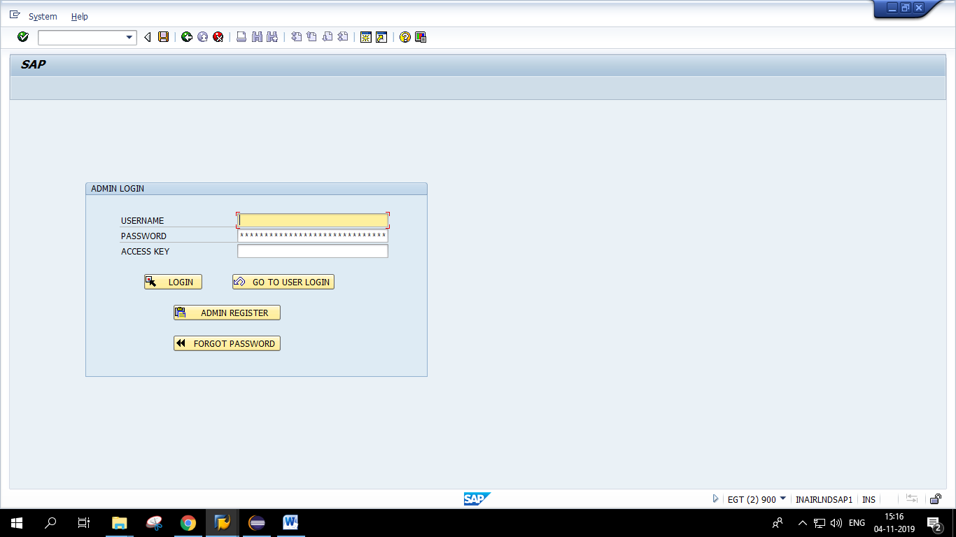

1. Registration screen for Admin.  
   This screen will take admin details and will produce an access key as an authorization key which has to be mailed back to admin.

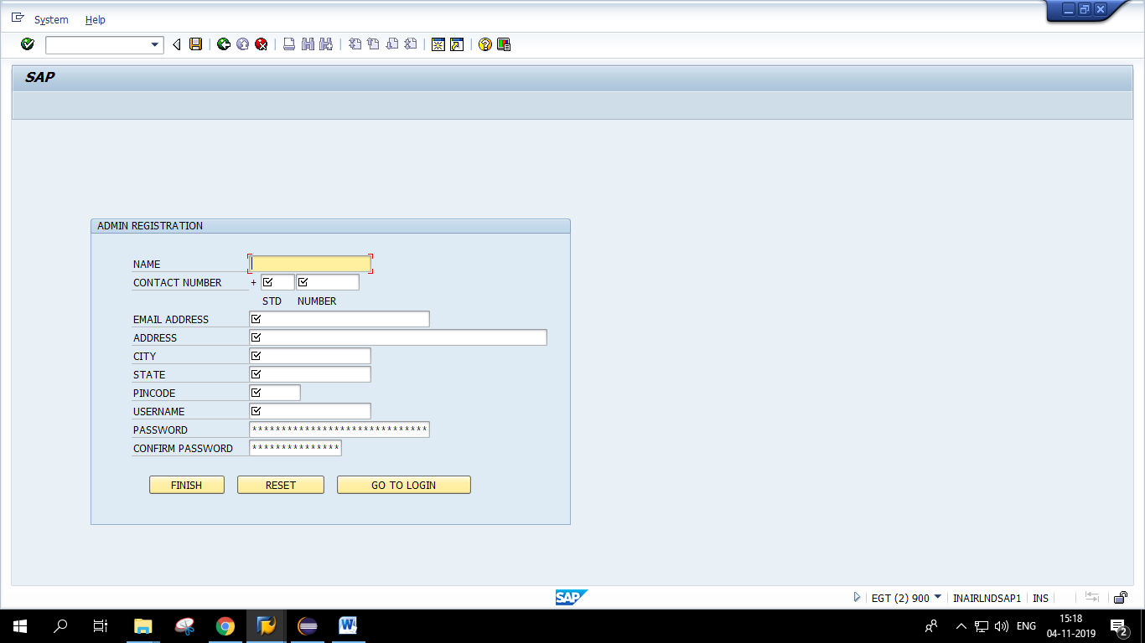

6. DML Functionalities for Admin with print PDF facilities.

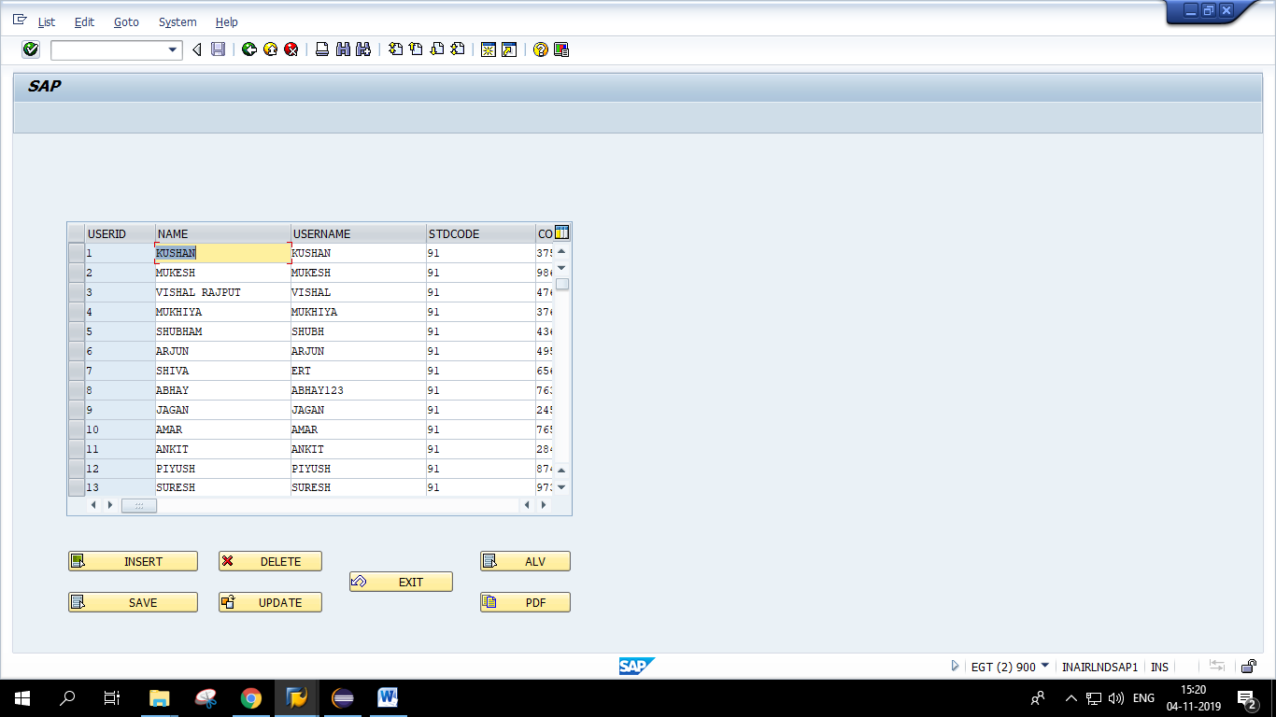

Tables

1. User Details Table –

* Username
* Userid
* Email
* Contact
* Stdcode
* Name
* Address
* City
* State
* Pincode
* Password

1. Admin Table

* Username
* Userid
* Access Key
* Email
* Contact
* Stdcode
* Name
* Address
* City
* State
* Pincode
* Password